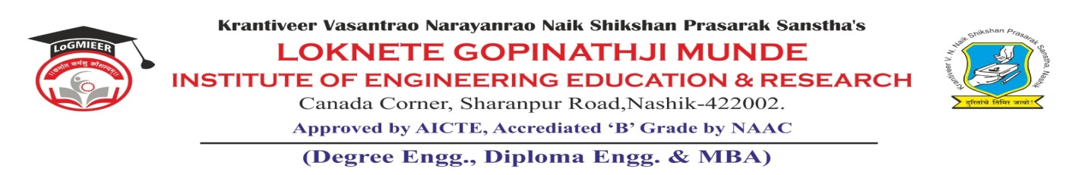
AD-301 | Activity Report | Academic Year: 2025-26
Rev-00 | Activity Report | Semester: I / II
DEPARTMENT OF MECHANICAL ENGINEERING
Particulars | Description
Activity | Expert Talk
Activity Level | Department Level
Title | Heat Treatment Processes: Bridging Fundamentals with Industrial Practices.
Speaker / Resource PersonName  Designation  Organization/Institute Name and address | Mr. Jayant P. Khairnar  Proprietor, Right Consultancy and Training Services, Nashik.
Organized by | MESA
Venue | SE Class Room
Date &Time | 2-09-2025
Objectives of the Activity | 1. To bridge the gap between textbook knowledge and its industrial relevance about heat treatment processes.  2. To interact with an expert provides career direction.
Outcomes of Activity | Better understanding of how fundamental heat treatment processes/principles used in industrial settings to optimize material properties for specific applications.
Targeted Participants | SE, TE students
Total No. of Participants, & % | 43 (75%)
Content of the Activity | Heat Treatment Processes, Case hardening processes and importance in view of industrial practices
Relevance to POs | PO1, PO2, PO3, PO4 and PO12.
Relevance to PSOs | PSO1 and PSO3
Methodology Used | PowerPoint presentation  Presentation with notes and comments  Discussion.
Brief Description of the Activity | Expert talk of Mr. Jayant P. Khairnar, was organized on 2nd Sept for second and third year students. The objective was to get practical exposure through case study, industrial experiences about heat treatment processes. The outcome of this activity was better understanding of how fundamental heat treatment processes/principles used in industrial settings to optimize material properties for specific applications.
Geo- tag photos of the Activity
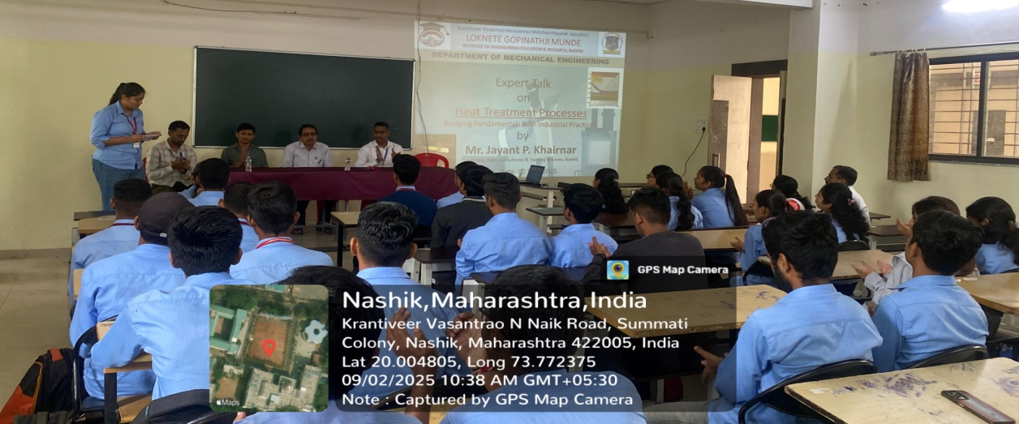

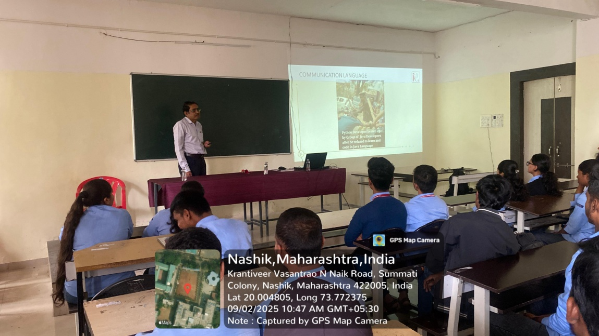

Dr. R. R. Chakule |  | Dr. R. R. Chakule
Activity Coordinator  Prof. S. Punde  Dean-Academics |  | HoD  Prof. N.V. Kapade  IQAC Coordinator

