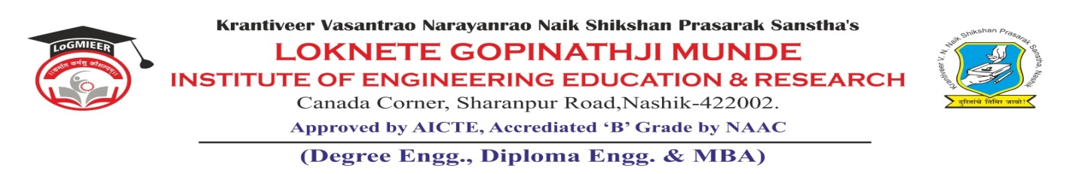
AD-301 | Activity Report | Academic Year: 2025-26
Rev-00 | Activity Report | Semester: I / II
DEPARTMENT OF MECHANICAL ENGINEERING
Particulars | Description
Activity | Expert Talk
Activity Level | Department Level
Title | Non-destructive Testing Techniques: Bridging Theory and Industry Practice
Speaker / Resource PersonName  Designation  Organization/Institute Name and address | Mr. D. S. Kulkarni  DGM, Godavari Technical Services, Nashik.
Organized by | MESA
Venue | SE Class Room
Date &Time | 26-09-2025
Objectives of the Activity | 1. To provide students with a comprehensive understanding of Non-Destructive Testing (NDT) techniques and their significance in engineering applications.  2. To bridge the gap between theoretical knowledge of NDT studied in Engineering Materials & Metallurgy and real-world industrial practices.  3. To develop awareness of quality control, safety, and reliability aspects in manufacturing, fabrication, and maintenance industries through NDT applications.
Outcomes of Activity | 1. Students understood the importance of NDT in detecting flaws and ensuring the integrity of engineering materials and components.  2. Understood working principles of various NDT techniques and differentiate between destructive and non-destructive testing methods.  3. Create confidence to Apply theoretical knowledge to analyze real-life case studies and industrial applications demonstrated during the talk.  4. Aware the role of NDT in improving product quality, reliability, and safety in industries such as aerospace, automotive, energy, and construction.  5. Gain awareness about industrial standards, codes, and certification programs related to NDT.
Targeted Participants | SE, TE and BE students
Total No. of Participants, & % | 29 (61%)
Content of the Activity | NDT techniques and industrial case study
Relevance to POs | PO1, PO6, PO9 and PO11.
Relevance to PSOs | PSO2
Methodology Used | PowerPoint presentation  Discussion  Interactive session.
Brief Description of the Activity | An expert talk on “Non-Destructive Testing Techniques: Bridging Theory and Industry Practice” was conducted on 26th September 2025. The session was delivered by Mr. D. S. Kulkarni, an industry expert, who shared valuable insights into NDT methods and their practical applications in engineering. The talk helped students connect theoretical concepts with real-world industrial practices and enhanced their understanding of material testing and evaluation.
Geo- tag photos of the Activity
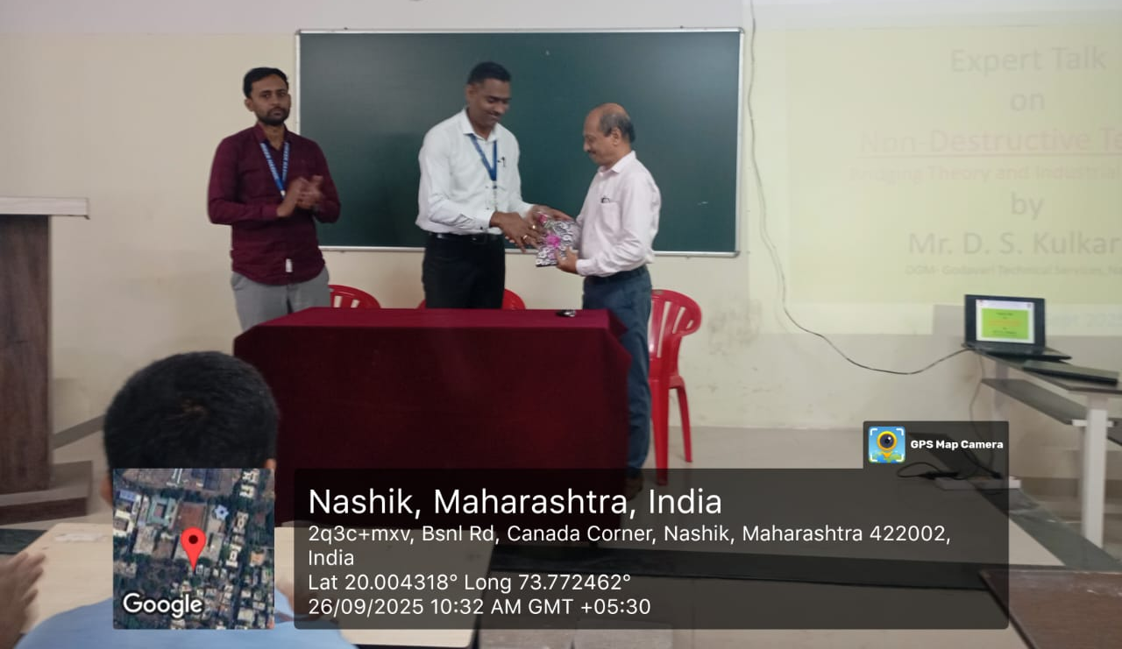

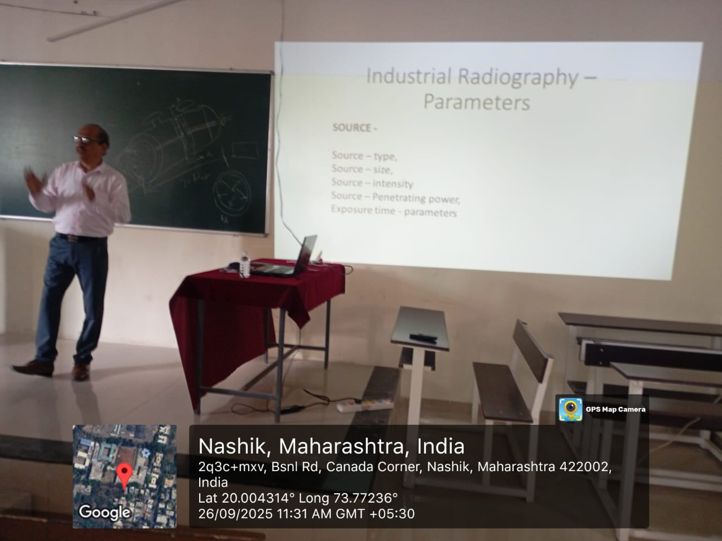

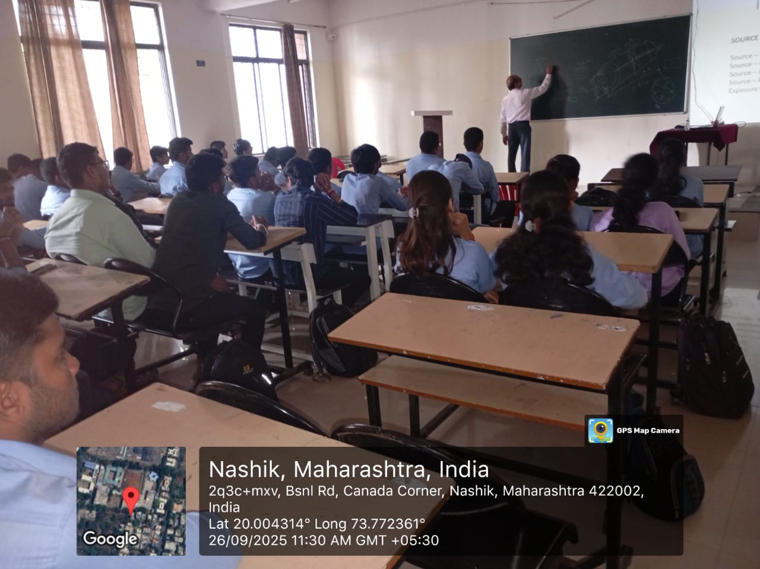

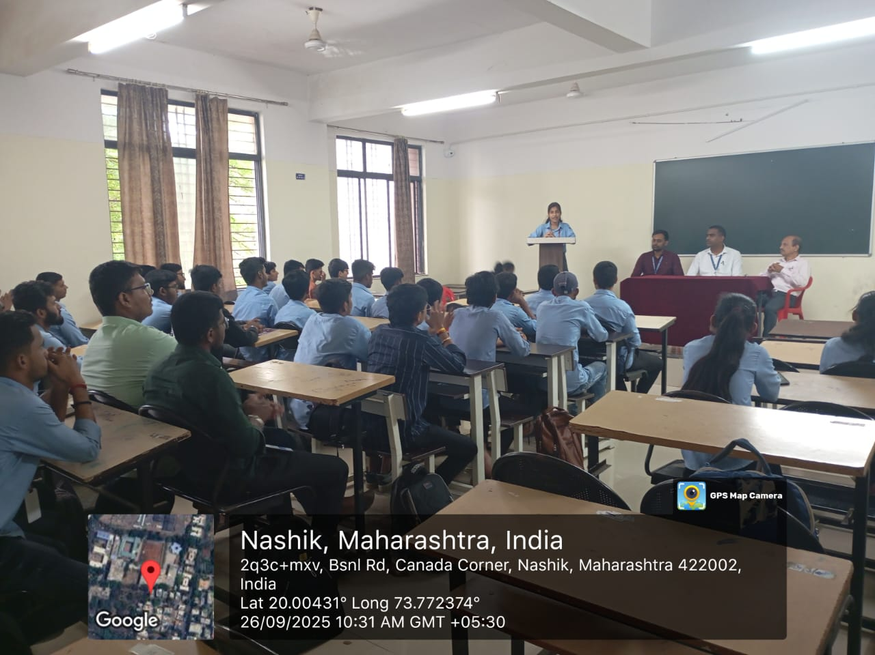
Dr. R. R. Chakule |  | Dr. R. R. Chakule
Activity Coordinator  Prof. S. Punde  Dean-Academics |  | HoD  Prof. N.V. Kapade  IQAC Coordinator

