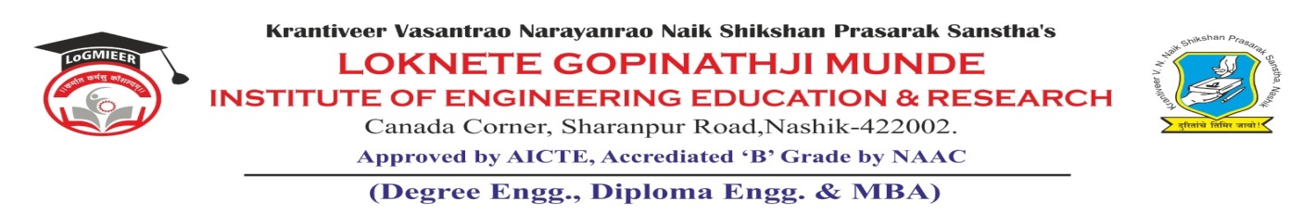
AD-301 | Activity Report | Academic Year: 2025-26
Rev-00 | Activity Report | Semester: I / II
DEPARTMENT OF MECHANICAL ENGINEERING
Particulars | Description
Activity | Workshop
Activity Level | Inter institute
Title | PLC & SCADA System
Resource Person Name | Dr. Sonali Akolkar  Head of Department (Applied Science)  LoGMIEER, Nashik
Organized by | Mechanical Department
Venue | TE Classroom & CAD Lab
Date &Time | 7th & 8th Oct 2025 , 12:30 – 4: 30 pm
Objectives of the Activity | - To provide participants with practical knowledge and hands-on experience in programming, operation, and troubleshooting of PLCs and SCADA systems used in industrial automation.  - To enhance students’ understanding of real-time monitoring, control processes, and industrial applications, thereby bridging the gap between academic concepts and industry practices.
Outcomes of Activity | - Participants gained the ability to design, program, and implement basic automation tasks using PLCs and SCADA systems.  - Students developed practical skills in monitoring and controlling industrial processes, preparing them for real-world applications in automation industries.
Targeted Participants | TE Student
Total No. of Participants, Participation % | 72 %
Content of the Activity | Introduction to PLC & SCADA, PLC Fundamentals, SCADA Fundamentals, Practical Demonstrations, Case Studies and Industrial Applications.
Relevance to POs | PO1, PO2, PO3, PO5, and PO11.
Relevance to PSOs | PSO1, and PSO2
Methodology Used | PowerPoint presentation  Practical demonstration  Presentation with notes and comments  Discussion.
Brief Description of the Activity | The workshop on PLC and SCADA systems was conducted to provide participants with practical knowledge of industrial automation and process control. The session introduced the fundamentals of Programmable Logic Controllers (PLC) and their applications in controlling machinery and processes. Participants gained insights into Supervisory Control and Data Acquisition (SCADA) systems used for monitoring and data collection in industries. The workshop also demonstrated real-time process monitoring and control using SCADA software. Case studies of industrial automation were discussed to highlight practical applications. Students learned about system architecture, communication protocols, and troubleshooting techniques. The activity enhanced technical skills, problem-solving ability, and prepared participants for industry-oriented challenges in automation and control engineering.
Geo- tag photos of the Activity  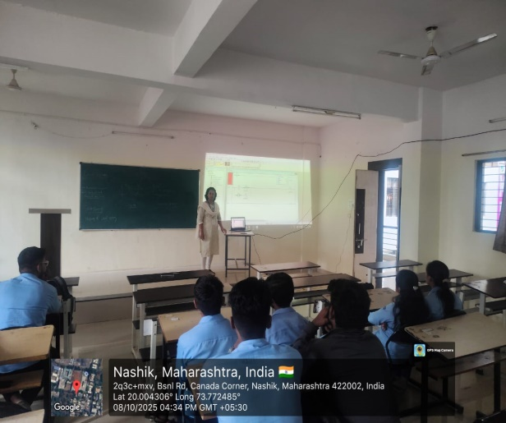  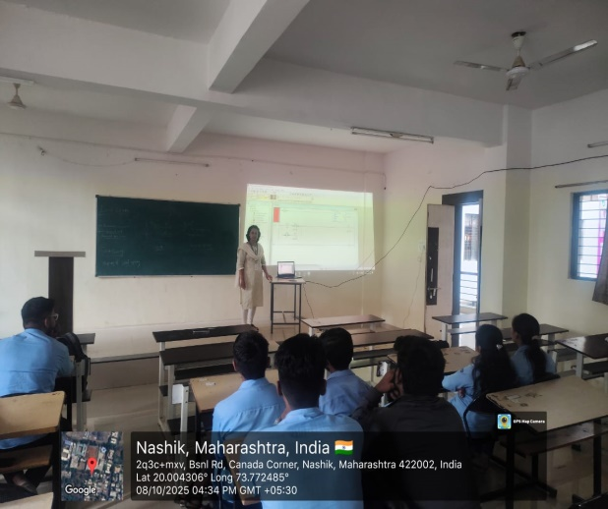 | 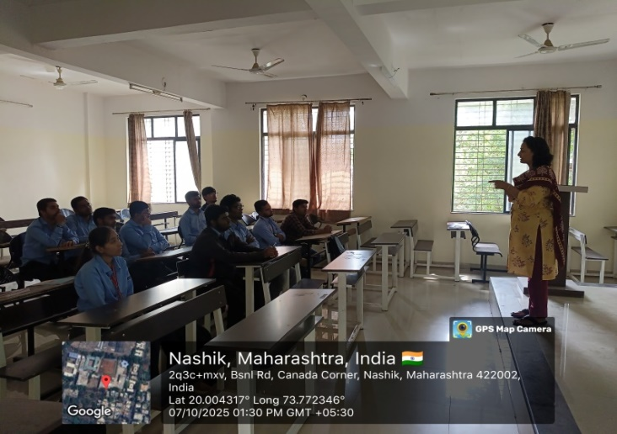  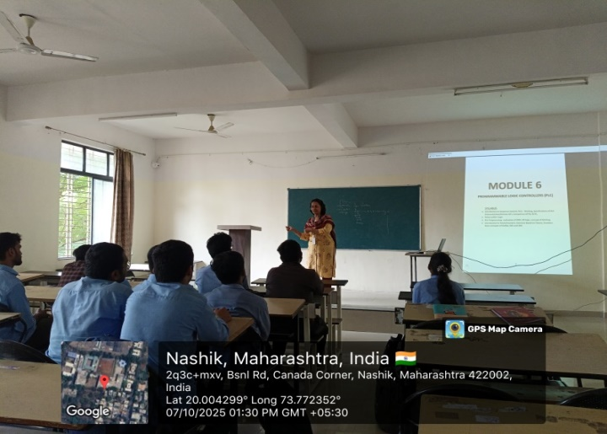
Prof. G. R. Khairnar |  | Dr. R. R. Chakule
Activity Coordinator |  | HOD

