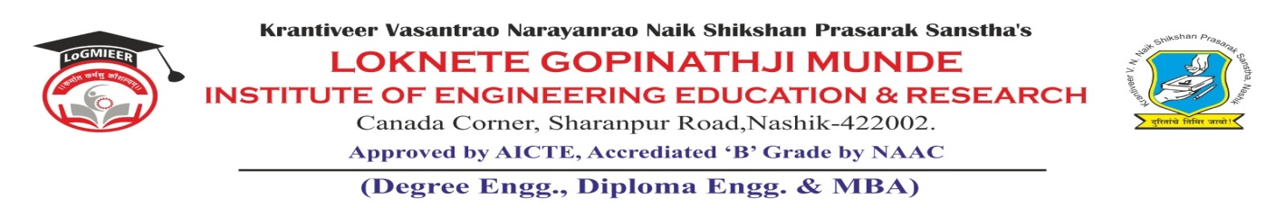
AD-301 | Activity Report | Academic Year: 2025-26
Rev-00 | Activity Report | Semester: II
DEPARTMENT OF MECHANICAL ENGINEERING
Particulars | Description
Activity | Value Added Course
Activity Level | Department Level
Title | 3-Day Value Added Course on “GD&T: Fundamentals & Applications
Speaker / Resource PersonName  Designation  Organization/Institute Name and address | Dr. Satish Maniyar, Founder & Director TECHNOCAD, Nashik
Organized by | Department
Venue | Seminar Hall & CAD Lab
Date &Time | 15-04-2026 to 17-04-2026
Objectives of the Activity | To develop understanding of engineering drawings using GD&T symbols and standards.  To bridge the gap between theoretical knowledge and industrial design practices.
Outcomes of Activity | After completion of the course, students will be able to:  - Understand and interpret GD&T symbols, terms, and concepts effectively.  - Apply geometric tolerances such as form, orientation, location, and runout.  - Define and use datums and feature control frames correctly.
Targeted Participants | SE, TE & BE students
Total No. of Participants, & % | 37 (50%)
Content of the Activity | GD&T Symbols, Datums, Rules, Form, Orientation, Location, Runout, Profile Controls & Practical
Relevance to POs | PO1, PO2, PO3, PO4, PO5 and PO10.
Relevance to PSOs | PSO1, PSO2 & PSO3
Methodology Used | Chalk with blackboard  PowerPoint presentation  Discussion.
Brief Description of the Activity | A 3-day value added course on “GD&T: Fundamentals & Applications” was conducted for Mechanical Engineering students to enhance their understanding of geometric dimensioning and tolerancing. The activity covered fundamental concepts, GD&T symbols, datum systems, feature control frames, and tolerance analysis with practical examples.  Interactive sessions, real-world case studies, and problem-solving exercises were carried out to help students interpret engineering drawings and apply GD&T principles effectively. Hands-on exposure to CAD/CAE tools was also provided to demonstrate the industrial application of GD&T.  The course successfully bridged the gap between theoretical knowledge and industry requirements, improving students’ design accuracy, technical communication, and employability skills.
Geo- tag photos of the Activity
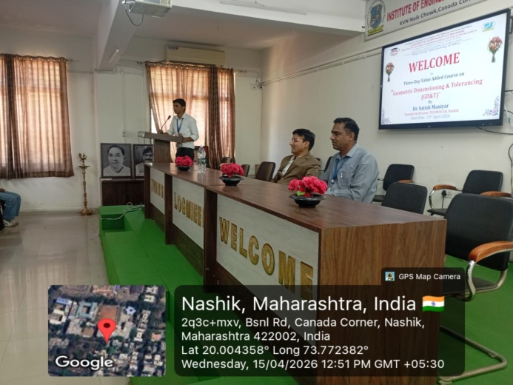 |  | 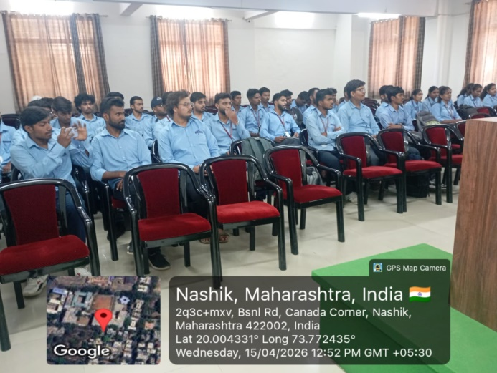
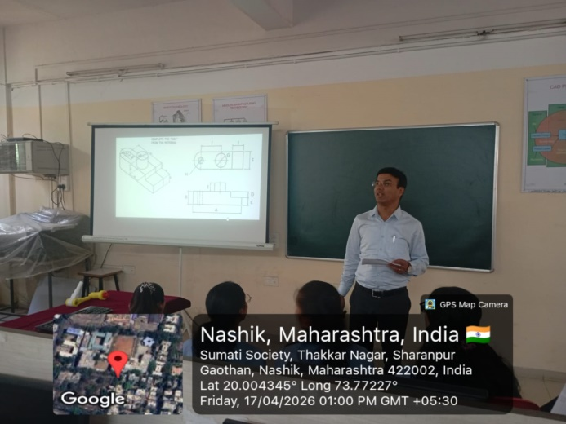 |  | 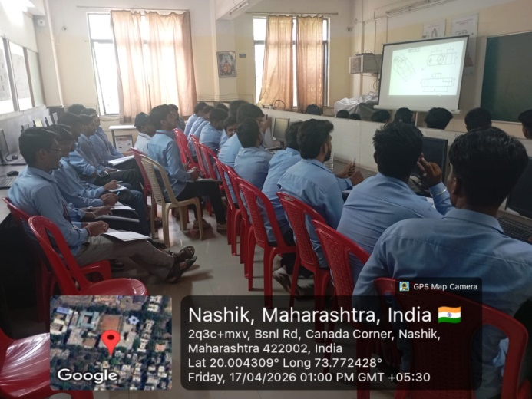
Prof. S. U. Nagare |  |  | Dr. R. R. Chakule
Activity Coordinator  Prof. S. S. Punde  Dean-Academics |  |  | HoD  Prof. N. V. Kapade  IQAC Coordinator

