
AD-301 | Activity Report | Academic Year: 2025-26
Rev-00 | Activity Report | Semester: I / II
DEPARTMENT OF MECHANICAL ENGINEERING
Particulars | Description
Activity | Value Added Course
Activity Level | Department Level
Title | 6-Day Value Added Course on “Python Programming and Artificial Intelligence & Machine Learning (AI/ML)”
Speaker / Resource PersonName  Designation  Organization/Institute Name and address
  Name | Designation | Orgnization
  Dr. B.S. Shirole | HOD,  Asso. Prof | LoGMIEER, Nashik
  Dr. R.R. Bhandari | HOD,  Asso. Prof | SNJB’s KBJ COE Chandwad
  Dr. K.R. Nirmal | HOD,  Asso. Prof | SNJB’s KBJ COE Chandwad
Organized by | Mechanical Engineering Department
Venue | Seminar Hall, CAD Lab (Civil, Mechanical)
Date &Time | Start Date: 04-04-2026  End Date : 24-04-2026
Objectives of the Activity | - To acquaint with fundamentals of artificial intelligence and machine learning.  - To introduce students to supervised, unsupervised, and reinforcement learning techniques, and enable them to acquire, visualize, analyze data, and develop classification and regression models using appropriate feature engineering methods.  - To expose students to advanced computational approaches including Markov processes, reinforcement learning, genetic algorithms, and neural networks, and facilitate their application in solving real-world engineering problems.
Outcomes of Activity | - Students got the opportunity to understand the fundamentals of Artificial Intelligence and Machine learning, including supervised, unsupervised, and reinforcement learning techniques.  - It was great exposure for the students to apply data acquisition, visualization, feature extraction, selection, and dimensionality reduction techniques to develop and evaluate classification and regression models.  - Students got the opportunity to explore and implement advanced approaches such as Markov processes, reinforcement learning genetic algorithms, and neural networks for solving real-world engineering
Targeted Participants | SE, TE and BE students of Mechanical Engineering
Total No. of Participants, Participation % | 65
Content of the Activity | Basics of artificial intelligence and machine learning. The content of this entire course
Relevance to POs | PO 1, PO 2, PO 3, PO 4, PO 5, PO 11
Relevance to PSOs | PSO 1
Methodology Used | PowerPoint presentation  Presentation with notes and comments  Discussion.
Brief Description of the Activity | The course was structured with a balanced approach, consisting of a 2-day theory session followed by 4 days of practical sessions. Theory sessions were conducted by Dr. Rajiv Bhandari and Dr. Khyati Nirmal, and practical sessions were conducted by Dr. Bajirao Shirole. It provided students with an opportunity to understand the fundamentals of Artificial Intelligence and Machine Learning, including supervised, unsupervised, and reinforcement learning techniques. Students worked with real-world datasets to perform data acquisition, visualization, and analysis, along with feature extraction and model development for classification and regression tasks. The practical exposure also included advanced concepts such as Markov processes, reinforcement learning, genetic algorithms, and neural networks, enabling students to apply these techniques to solve real-world engineering problems and gain hands-on experience.

Glimpse of Value Added Course
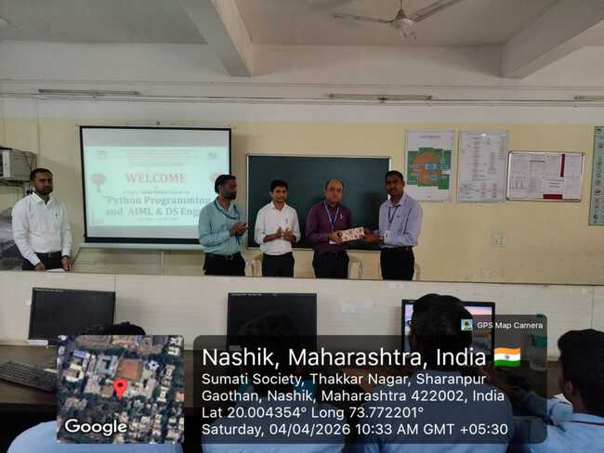
Day-1 Inaugural Session of 6 Days Value added course
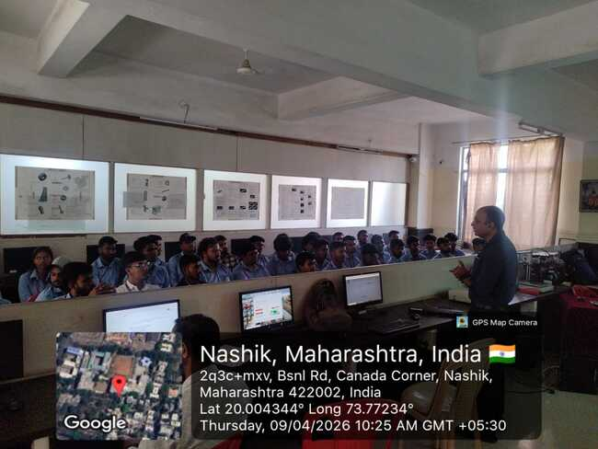
Day - 2 - Dr. Shirole sir conducting practical session

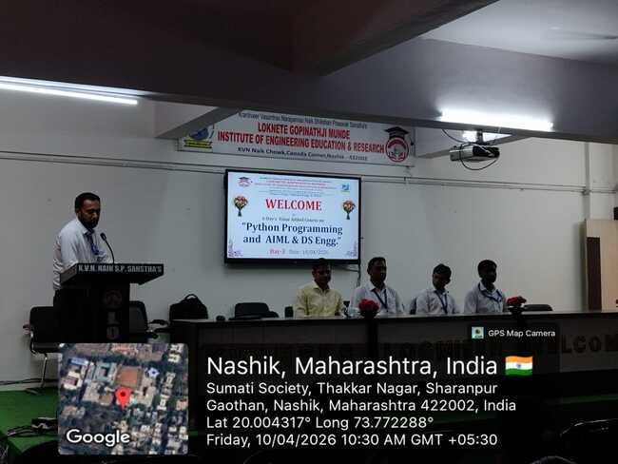
Day-3 Felicitation of Dr. Rajiv Bhandari
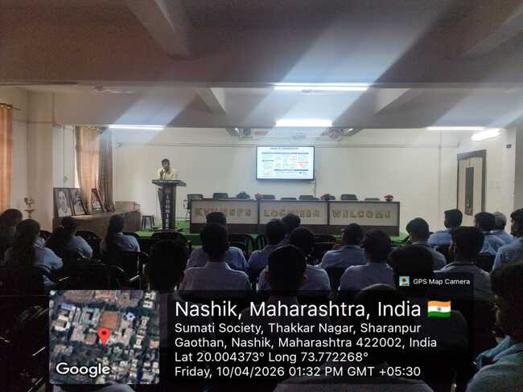
Day-3 Dr. Rajiv Bhandari delivering session on AIML
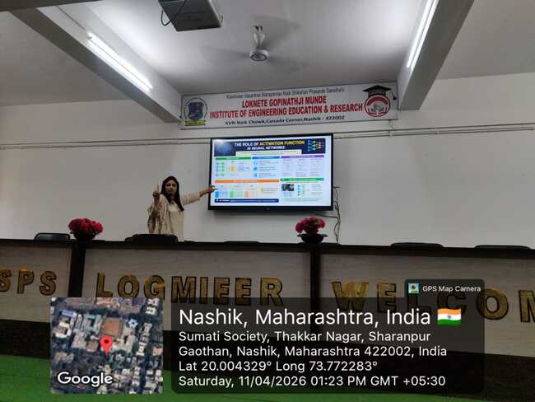
Day-4 Dr. Khyati Nirmal Delivering session on Data science and Analytics

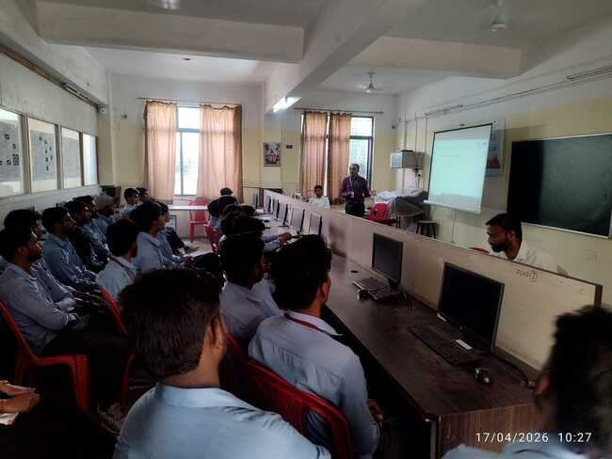
Day-5 Dr. Shirole Sir Conducting Practical Session

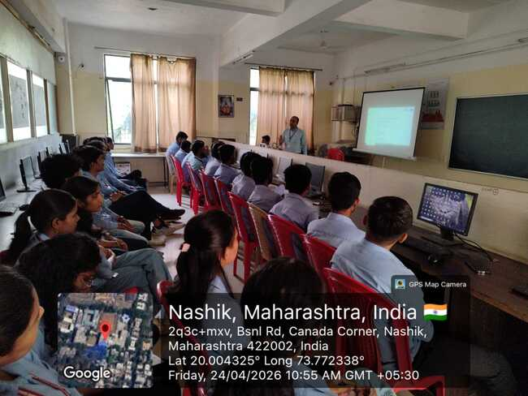
Day - 6 - Dr. Shirole sir conducting practical session

Prof. S. P. Pawar | Dr. R. R. Chakule
Activity Coordinator | HOD

