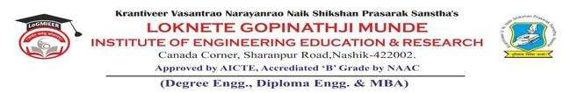
AD-301 | Activity Report | Academic Year: 2025-26
Rev-00 | Activity Report | Semester: I / II
DEPARTMENT OF MECHANICAL ENGINEERING
Particulars | Description
Activity | Expert Talk on the eve of Teachers Day
Activity Level | Department
Title | Teachers Day Celebration  Expert Talk on “Current Industry Scenario and Opportunities for future Engineers”
Speaker / Resource PersonName  Designation  Organization/Institute Name and address | Er. Dhananjay R. Gavande  Business Development Manager  The BAAP Company, Sangamner, Ahilyanagar
Organized by | MESA
Venue | TE Mech Classroom
Date &Time | 04 ^{th} Sept.2025. 01 pm to 3 pm
Objectives of the Activity | - To Celebrate the Teachers Day  - To bridge the gap between academic learning and industry expectations.  - To familiarize students with the latest trends, challenges, and developments in the current industrial scenario.
Outcomes of Activity | - Students gained knowledge about the present state of industries and the evolving job market.  - Students became aware of upcoming opportunities in various engineering domains and how to prepare for them.  - Students understood the importance of developing technical, analytical, and soft skills required for employability.
Targeted Participants | SE, TE, BE
Total No. of Participants, Participation % | 35
Content of the Activity | - Role of engineer in quality and quality assurance.  - Cross functional collaborations  - Other key career sectors in Mechanical Engineering  - Recent Trends- Green Engineering, 3 D Printing, IoT and AI  - Essential Skill- Technical + Soft Skills
Relevance to POs | PO 07, PO 08, PO 9, PO 10, PO 11,
Relevance to PSOs
Methodology Used | PowerPoint presentation  Presentation with notes and comments  Discussion.
Brief Description of the Activity | On the occasion of Teachers’ Day, an Expert Talk was organized on the topic “Current Industry Scenario and Opportunities for Future Engineers”. The session was delivered by Er.Dhananjay Gavande, esteemed alumni of 2014-15 batch. He highlighted the role of engineers in quality and quality assurance, the importance of cross-functional collaborations, and the various career avenues in Mechanical Engineering. The expert also discussed recent industry trends such as Green Engineering, 3D Printing, IoT, and Artificial Intelligence, emphasizing their growing impact on engineering practice. Furthermore, the session underlined the significance of developing both technical expertise and soft skills for career success.
Memories
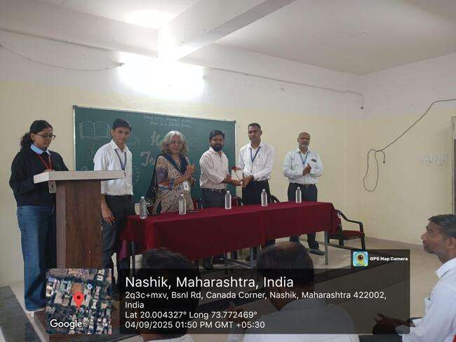

Head of the Department Dr.R.R.Chakule Felicitating Er. Dhananjay Gavande
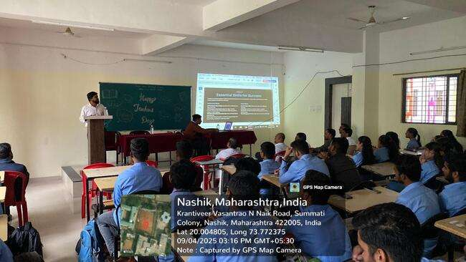

Er. Dhananjay Gavande Delevering a talk
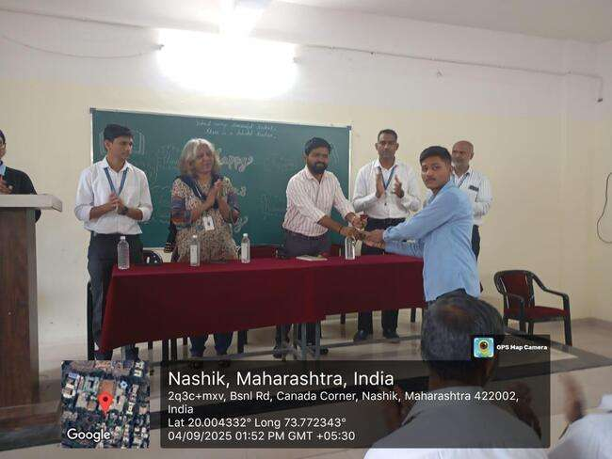
Er. Dhananjay Gavande Felicitating MESA Office Bearers

Prof. S. P. Pawar | Dr. R. R. Chakule | Prof. S. S. Punde | Prof. N. V. Kapade
Activity Coordinator | HOD | Dean Academics | IQAC Coordinator

